in the name of God

Feasibility study, technical, financial, economic:
Leech breeding
10000 productive
And with a production capacity of 250,000 pieces
per year

executor of plan:
Nedaye Asayeshe Baharestan NGO

Location of the project:
Baharestan county, Tehran province, Iran

Arranged in July 2019

HOSSEIN MASHADI FARAHANI

Legal status of the project:

Reasons for choosing a project location:
• Compassionate, committed and facilitating managers in the city
• Plenty of usable space
• Proximity to consumption centers and raw materials (Tehran, Qom and Alborz, etc.)
• Excellent access to roads and communication routes such as "Ayatollah Saeedi" Highway and "Saveh" Road.
• Extensive young and capable workforce
• Compliance with other programs in eliminating social harms and job creation
• Access to water, gas, electricity, energy and communications
Leech breeding
If you are considering leech breeding, you should buy leech larvae or baby leeches and keep them for 6 to 6 months according to the instructions you have received, and feed them twice during this time. After this period, the leeches have reached the medical average and are ready to be marketed, and at least 60% of the leeches can be sold with an approximate profit.
Out of 650 species of leeches, only 15 species have medical applications.
The presence of more than 40 species of freshwater leeches has been reported in Iran.
The body of a leech is divided into about 34 (Segment) rings.
Leeches have both male and female sexual organs at the same time, but at birth they have only male sexual organs.
It reaches sexual maturity after about 4 months from birth
In cases where the leech does not feel calm, it may not lay eggs for up to 9 months
They have 3 to 4 or 5 pairs of eyes. The number of eyes and the order or manner of their placement in different species is different.
The sensory organs on the leech's head enable it to detect changes in light intensity, temperature, and vibration.
Chemical receptors on leeches' heads create a sense of smell
Leeches are very sensitive to movement in the water and their activity peaks at night and during rainy times.

In the method of leech reproduction, instead of leech larvae, productive and adult leeches are prepared. Reproduction will be done with a coefficient between 20 and 60, and after the birth of a leech baby, the rest of the steps are like leech breeding. In the method of leech reproduction, after 12 to 24 months, profitability was reached, which is much higher profit in leech reproduction than leech breeding. Of course, the combined method is also possible, as some producers use both methods of reproduction and breeding of leeches in combination and simultaneously.

The purpose of this project is to set up a leech breeding unit, which first buys 10,000 mother leeches and sells them after keeping the born leeches.

The leech lays its eggs when it feels calm, that is, when it is full and feels safe from the outside environment (excessive water movements are one of the things that disturb the leeches' calmness).
Each leech lays about 20 to 80 eggs.
According to the studies conducted in the market research department of "Masiha Teb Shomal" Company, the daily consumption of leeches in the country is over 30,000.
Leeches cost between $ 6 and $ 8 in Europe and the United States.
The price of leeches in Iran is a function of the season and time of fishing.

Suitable place for leeches breeding:
- Natural pond or pond.
- Cement pond.
- Creating a pond with waterproof fabrics.
- Plastic tanks.

Leech breeding and reproduction
Sexual maturity of medical leeches (Herod family) is after 1-2 years. Of course, high temperature (20 to 29 degrees Celsius) and timely and proper nutrition will help leeches to reach these conditions and cause them to grow.
Mating of leeches will occur at temperatures above 20 ° C in water or on land, after which the leeches will begin to cocoon within one to nine months, depending on the living conditions of the leeches, including the amount of water, temperature, light, humidity, and so on. Leeches will determine the amount of rest and ....
In breeding, by dividing the ponds, the grading of the leeches will be done better, as a result of which the selection of grown leeches for breeding will be easier, and in leech breeding, obtaining the number of leeches artificially will not be a difficult task.
And the cost and difficulty of feeding will be very low, which will be possible with the implementation of high management.
Egg-shaped sponge cocoons, which are about 1-2 cm, which means that the sponge wall of the cocoon retains moisture, which is the liquid inside the egg.

Feeding leeches in breeding conditions
Feeding leeches in artificial breeding environments is one of the most challenging and important parts in breeding and breeding leeches and is the question of most friends who intend to enter this industry. In this article, the feeding conditions of leeches and various feeding methods We will briefly state.
In Southeast Asian countries such as Malaysia and China, where leeches are raised in an open environment or water tank, due to the abundance of animals such as eels and catfish, etc. are used to feed leeches so that these animals in feces. They enclose the metal so that the animal is not very mobile and then put the cage in the tank to which the leeches cling and start feeding, which of course is not possible on a large scale and has no economic justification.

In leeches’ farms that are set up in ponds and wetlands, a coexisting animal such as a frog is used to feed the leeches, so that by releasing the frog in the leech breeding border, the leeches' food is provided by eating the frog's blood. It is not possible to run everywhere and it has its own difficulties.

In countries such as Russia and Germany for leeches farming Industrial Q Fresh cow blood is used, which is the best nutrition for leeches, fresh and healthy blood.
Research centers use the blood of mice and rabbits for testing.

The best and easiest way to feed leeches is to use sieve and fresh blood, which can be easily used in industrial dimensions, so that we heat the blood according to the required amount (up to 30 to 34 degrees) that the leeches feel It clings to the body of a real animal and feeds more easily. Then we pour the blood into the container and put the sieve on the blood with a distance of 1 cm and we pour a certain number of leeches on the sieve so that the leeches stick to the sieve and start feeding.
Note: This explanation is generally stated and feeding in this way has many points and many details that non-observance of them will definitely cause problems for leeches

Leech nutrition for therapeutic purposes

If the goal is to provide leeches to leech treatment centers, the leeches should be fed a small amount to reach only the average size, which takes about 6 months to reach the other average for therapeutic use and should be at least 3 to 4 months at 20 degrees. Store without food for 24 degrees until the eaten blood is completely digested and ready for therapeutic use, because if the leech is full and there is blood in its body, it either does not stick to the host or eats less blood after sticking.

Leech breeding in natural ponds
In this method, a large number of leeches can be raised, but the collection and grading of leeches will be difficult. In these conditions it depends on the natural conditions.

In this breeding method, water inflow should always be controlled in terms of pollution, because it is possible that agricultural pesticides used by farmers do not enter the catchment, which causes water pollution and leech losses.
In order to collect leeches in small size, in this breeding method, bait is used, but in order to collect leeches and their cocoons completely, the pond must be emptied and then the leeches can be collected from inside the flower.
Water outflow should also be controlled in this way because emptying the pond will cause the pond to dry out, resulting in hunting and loss of leeches.

Store in cloth bags
Storage in cloth sacks is much easier and less expensive than other breeding methods, but most of the transportation is used for leeches.

The advantages of keeping leeches in these species are:
Leeches are graded more diverse and easier
Provides suitable environmental conditions such as leech burrow or hive
Transporting and changing water and feeding it is done quickly and easily
. Protected from predators like birds
Makes leeches almost impossible to escape from this environment

Disadvantages of storage in cloth bags:
Dirty sack and need frequent washing
Insects such as mosquitoes gather on dirty sacks and lay eggs
Do not observe the activity of leeches that need to be opened frequently
In general, this method is better to be used only for transportation

Breeding leeches in glass bottles
This breeding process is done in countries where open space is not suitable for leeches breeding, such as Russia, due to frost, they are forced to breed leeches inside controlled halls.
Also, in controlled environments, it can be propagated artificially and out of season, while in open environments, all conditions are in the hands of nature.
In countries like Malaysia, Thailand, China, outdoor breeding is done.
The glass of the breeding bottles makes the monitoring and controls very precise, but it will increase the labor cost very much.
It goes without saying that in glass bottles, only leeches can be kept and raised, and in no way are these glasses suitable for reproduction.

Breeding leeches in the aquarium
. One of the advantages of this method is the complete observation of the movements and growth changes of leeches, which we will have more control over, which will lead to more accurate grading.
- The size of aquariums is about the size of an ornamental fish aquarium.
- Height about 40 cm Length about 1 m Width about 40 cm.
- Two thirds of the aquarium are filled with water and there is empty space above it.
- It has a lid and proper ventilation.
In such halls, low new lamps with variable light intensity are used.
Such salons are usually used for research work or for direct consumption of leeches in medicine.
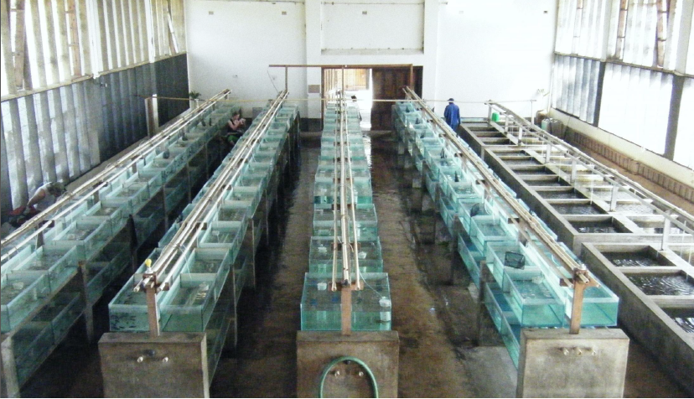

Raising leeches in plastic tubs
Keeping leeches in these tanks allows the breeder to have better management than the farm
On average, a maximum of 50 leeches are kept in every 10 liters of water.
Each tank has two drainage outlets, one at the bottom of the tank and the other at 30-40 cm of the tank, which is used as a head.
Water enters from above through a piped network from the water storage tank.
The environment inside the tank can be free of additional materials that will require more control and can be similar to mud and cement pools containing materials and equipment such as natural mud or clay of aquatic plants. Leech Island. Brick and pottery pieces and... Be.
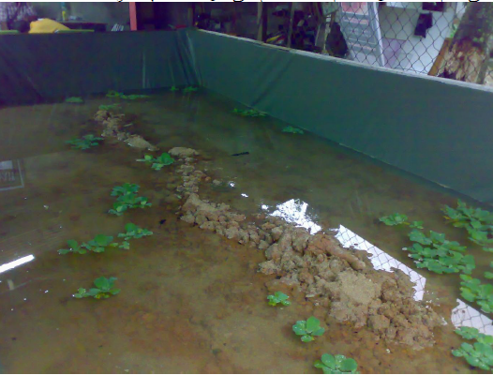
Keep in a tarpaulin pool
Due to the high-density texture and waterproofing with suitable materials, the tarpaulin fabric is durable and impermeable, and making a pool with it is done in less time and easily, so that a layer of tarpaulin is placed inside it after excavation. Data and it can be used as a breeding pool or created at the height of the tarpaulin pool

And no more need for building materials such as plaster. Cement and... It will not only reduce the cost of raising leeches, it will also disrupt the tarpaulin pool and transport it quickly, and will incur lower costs and damages when doing the work.
The rest of the care and maintenance in the tarpaulin pool is similar to the cement pool, which has been avoided.
The tarpaulin pool does not contain drainage on the floor and its drainage is by suction or suction.
Tarpaulin pools are installed both in depth and in height.

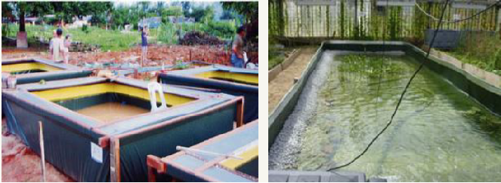
Breeding leeches in a concrete pool
Cement pools are similar to mud pools, except that the management of the pools is entirely up to the breeder and minor differences will be mentioned.
In industrial mode, 500 leeches are considered for each cubic meter, but the best conditions for breeding are 200 leeches in each pool. The height of the pool is about 70-80 cm of cement and brick, 200 cm long, 120 cm wide (pools). The smaller they are, the easier they are to manage.) The floor of the pool is paved with a solid cement block or rubble or 15-20 cm of cement pool floor.

Cement pool can be built both in height and depth. Inside the pool, some stone or pottery such as an earthenware vase is placed to provide a dark and safe place for leeches to rest. The height of the water inlet pipe should be lowered and about 3-5 cm away from the water surface to reduce the intensity of water fall and not damage the leech platform.
The pool drainage pipe is located at a depth of 30 cm from the depth of the pool so that when changing the water, we can only change part of the water.

Another drain should be placed at a height of 3 cm to drain all the pool water for emergencies.
The top of the pool has an awning to prevent direct sunlight and direct rain. Rainfall can change the pH of the pool water. Takes.
Cement ponds can be easily divided due to the geometric shapes of square cubes and rectangular cubes, so that leeches can be placed in them in a graded manner, which will help the management of leech breeding.
Fencing around cement ponds is necessary because leeches can cling to the concrete wall and climb out of the pool and escape. In cement ponds, litter can also be used.

The best water is mountain spring water, which has less solutes at low temperatures and, most importantly, has a constant quality throughout the year. Also, in winter, the water does not freeze and creates an open system. It is used which will reduce the total costs in leech breeding (including filtering water, changing water and balancing water temperature, etc.).

General factors to know before you start

Water:
- No chlorine ion
- Carbonate hardness less than 9DGH
- PH less than 7 (about 6.6)
- Ammonium less than 0.5 mg / l
- Nitrate less than 25 mg / l
- Nitrite less than 0.4 mg / l
- Absence of heavy metals

Storage environment:
- Semi-dark environment
- Stagnant water or fresh stagnant water
- Suitable bed for rest and movement (presence of vegetable clay and objects that can be attached to the leech balloon)
- Canopy in sunny environment
- Barrier to prevent the entry of leech predators such as birds
- Delicate net barrier to prevent leeches from escaping
- Installation of platform (island) inside the aquatic environment for resting mating and cocooning of leeches
- Stay away from noise and vibration pollution
- Existence of aquatic plants for water treatment, shading, cocooning and peeling

Earthen ponds for leeches
1) One third of the depth of the pool soil, including clay or vegetable clay, is about 20 to 30 cm
2) One third of water is about 20 cm
3) One third contains empty space

This type of breeding method is more suitable for those who want to work in open environments
This method is actually only used to keep leeches and has a very low efficiency for reproduction because there is no care and no management in this method and everything goes naturally.
This method is not recommended for reproduction at all.

How to cocoon leeches?
There is usually a time interval between mating and cocooning, most likely the time it takes for sperm to move from the body cavity to the ovaries.
However, some species may store sperm and fertilize under ideal conditions.
Such a time delay in medical leeches of Herodomedicinalis reaches more than 9 m before cocoon formation and the eggs remain at the same stage of growth.

The structure and production of cocoon in Herodine is quite similar to that of
"Kam Taran".
The clitellum glands secrete cocoon around the leech's body and fill it with albumin.
Most leeches attach their cocoons to a bed, which is first prepared by secreting an anterior (frontal) balloon.
Leeches lay eggs on the bed in the area prepared by the clitellum, then secrete the cocoon on the bed around the eggs. This bed can be anything from a mockery or a stick or even the exoskeleton of living things.

The leech twists after cocooning and closes both ends of the cocoon with secretions from the front balloon.
The cocoons become dark and hard after a few days. The cocoons laid by the leeches of Herodo-medisanalis after a month, the young leeches are ready to leave it. Injected feed so that in the last days of the night larvae leeches

They have become a mother leech coming out of the double holes of the cocoon.

Digestion and absorption of food in leeches
After adhering to the host, leeches begin to tear the skin or mucosa with their three horned J-shaped jaws, and in general the mouth balloon acts like a vacuum system, pumping blood to the middle of the gastrointestinal tract. It is pumped and after excreting most of the blood water, its concentrated and dense part is stored in the leech stratifier and is digested slowly within several months. Leeches contain bacteria in the gut that help digest food.

Blood-sucking leeches, such as Hirodo-medicinalis, have a bacterial species called Aeromonas hydrophila in their gut that has two very important functions.
1) This bacterium secretes an antibiotic that inhibits the growth of other bacteria and subsequently delays the breakdown of blood that remains in their digestive system for a long time.

2) This bacterium contains enzymatic substances that play an important role in the digestion and absorption of leeches’ food. He can eat several times his own weight in one meal.
The leech that is feeding must separate and extract the blood water from itself, which starts from the beginning of blood suction so that it leaks out of the walls of the leech's body.

Appearance of medical leeches
Medical leeches come in a variety of colors, often dark olive to brown or black or fawn, with stripes of olive green to green stretched across their bodies. Medical leeches can be drawn on two thin, colorful lines. The back detects that their lateral margins (from the back to the abdomen) are yellow-orange. The abdomen is usually very colorful and may have a color. The science of this animal is Herodotus officinalis.
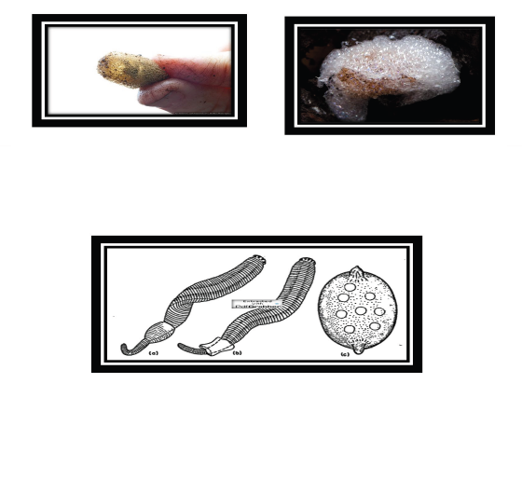
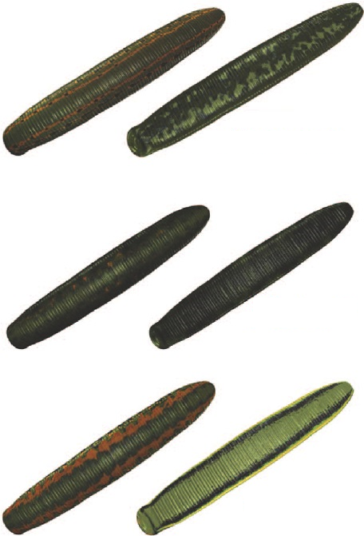

Physical and chemical factors affect the abundance and spread of leeches :

- Access to food organisms
- Bed composition
- Type of water
- Blue body type
- Water depth
- Water temperature
- Existence of water currents
- Dissolved oxygen
- Turbidity and types of pollution
- Hardness and pH of water

In general, the abundance and accumulation of leeches in coastal areas is higher than habitats such as stagnant water where submerged aquatic plants have developed. he does.

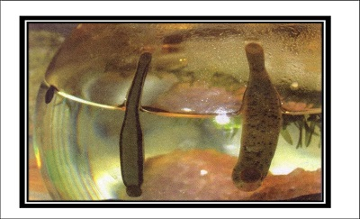

Symptoms of leeches' appetite for food:

• Leeches swim on the surface of the water and make vertical shots and observe sine waves in the water
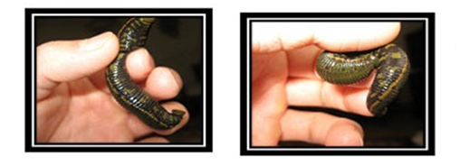
Normal mucus secretion is one of the symptoms of food in leeches. Mucus secretion usually begins after a period of 3 months of starvation (mucus is usually secreted from the upper lip of the front balloon into the head area).
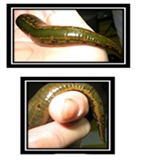
• When a leech is hungry, it has wrinkled skin and sometimes it folds! But after feeding, it becomes quite bulky and stretched to store more blood.

Leeches move by two front and rear balloons with the help of various muscles designed for different postures.

• The mucus secreted from the upper lip of the leech's mouth helps the balloon move back and forth with pumping movements of the throat so that it can create a strong suction pressure to move.

• This sticky material (mucus) and the operation system of the front and rear balloons allow him to move on any surface, even if the surface is oily and vertical.

Due to their special muscular characteristics, leeches can stay attached to a point for hours or days at a time, attaching only their rear balloon somewhere and staying there for a long time without moving.
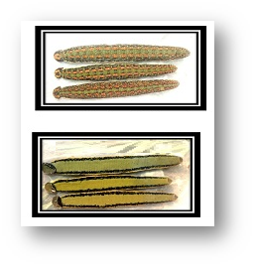
Leeches have a variety of muscles, each of which helps him to move in different environments so that he can move in the most difficult situations and even in low oxygen water.

summary of the report

Title of activity | Feasibility plan for leech breeding
Capacity | 250000 | pieces | leech
 | 0 | 0 | 0
Executor of the project | Nedaye Asaeyesh Baharestan NGO
Location | Baharestan city of Tehran province
Employment of the project | 6 | people
Fixed capital of the project | 3,160 | Million Rials
Total investment of the project | 4,424 | Million Rials
The amount of land | 500 | square meters
The amount of land | 186 | square meters
Amount of required facilities | 3,539 | Million Rials
Type of facility | loan | loan
Current breaking point | 46 | percent
Return on investment | 1.5 | year
Return rate on investment | 59 | percent

Row | name | National number
1 | Dr. Farid Kamalipour
2 | Hossein Mashhadi Farahani

Company Name | Institute Company Type | Type Registration Number | Place of Registration | Date of Registration
Nedaye Asasheye Baharestan NGO | Non-Governmental Organization | 508 | Tehran | 21/6/2019

نوع فعالیت یا محصولات تولیدی :
Row | Name of product | Production scale yearly | scale | (Rials) sales price
1 | (MEDICINEAL- Leech oil & ETC…) LEECH | 250000 | piece | 15000
2 | Leech production training for socially disadvantaged people | 100 | person | Free
LAND million rials
Row | title | Amount Unit | scale | Price Unit | Cost | Cost Remaining | Total Price
1 | land | 500 | square meters | 500,000 | 250 | 0 | 250
Note: In case of free land allocation by the relevant departments, this cost may be in a situation where there is no need for landscaping or minor repairs or changes are sufficient, and thus this cost can also be eliminated.

Landscaping million Rials
Row | Description Unit | Amount Unit | scale | Price Unit | Cost | Cost Remaining | Total Price
1 | Leveling, excavation and embankment | 750 | cubic meters | 30,000 | 23 | 0 | 23
2 | Land reinforcement, concreting | 275 | square meters | 70,000 | 19 | 0 | 19
3 | fencing with a height of 2 meters | 116 | square meters | 300,000 | 35 | 0 | 35
4 | entrance doors | 6 | square meters | 1,200,000 | 7 | 0 | 7
5 | Scheduling, canalization and street planning | 50 | square meters | 20,000 | 1 | 0 | 1
6 | Green space | 75 | square meters | 180,000 | 14 | 0 | 14
7 | Parking place | 25 | square meters | 250,000 | 6 | 0 | 6
8 | brightness | 10 | Number | 500,000 | 5 | 0 | 5
total sum |  |  |  |  | 109 | 0 | 109

Note: In case of free land allocation by the relevant departments, this cost may be in a situation where there is no need for landscaping or minor repairs or changes are sufficient, and thus this cost can also be eliminated.

Construction: million Rials
Row | Description Unit | Amount Unit | Price Unit | Cost Remaining | هزينه انجام شده | باقيمانده | Total Price
1 | indoor reproduction room | 50 | square meters | 4,500,000 | 0 | 225 | 225
2 | warehouse building accessories and parts | 25 | square meters | 5,000,000 | 0 | 125 | 125
3 | leeches breeding and maintenance space | 75 | square meters | 5,000,000 | 0 | 375 | 375
4 | house of guards and workers | 12 | square meters | 5,000,000 | 0 | 60 | 60
5 | 5 raw material warehouse and product | 24 | square meters | 5,000,000 | 0 | 120 | 120
total |  | 186 |  |  | - | 905 | 905

Office and welfare furniture million Rials

price sum | left | amount of the cost incurred | PRICE scale | Number of units | scale | Description
6 | 6 | 0 | 2 | 3 | Complete set | Complete set of table and chairs
0 | 0 | 0 | 25 | 0 | Complete set | Complete set of office furniture
40 | 40 | 0 | 4 | 10 | Complete set | Complete set of dressers, file, .... (average)
10 | 10 | 0 | 10 | 1 | Complete set | 1 Computer device and its accessories
0 | 0 | 0 | 10 | 0 | Complete set | Complete set of other office equipment (TV, etc.)
0 | 0 | 0 | 75 | 0 | Complete set | Complete set of network and internet
56 | 56 | 0 | 122 | 14 | total

General facilities and equipment with their technical specifications million Rials
Total cost estimate | Remaining amount | done | description |  |  | Row
15 | 15 |  | Bifurcation line and connections 1 | string 1 | water rating | 1
75 | 75 |  | 15 kW | string 1 | power rating | 2
45 | 45 |  | Electricity 3 phase switchboards, transformers fuses and other accessories with 100 meters | 3 series | Electrical switchboards and transformers | 3
15 | 15 | - | transmission line | 1 series | Gas supply points | 4
25 | 25 |  | electric motor, pipes, shafts, pods and pumps1 Series gas piping and fittings5 | 1 series | Gas piping and fittings | 5
25 | 25 |  | pipes, shafts, pods and pumps | 1 | 5000 thousand liter water tank | 6
95 | 95 |  | pipe, shaft and pump | 1 | industrial purifier | 7
25 | 25 |  | ton0.5 | 2 Number | BASKOOL | 8
65 | 65 |  | Internal networks | 16 cameras | CCTV | 9
35 | 35 |  | Kg12 | 15 Number | fire extinguishers | 10
420 | 420 | 0 | total

Equipment million Rials
Value of equipment | Price of machine | Number of series | units | manufacturer |  | Description  of specifications of equipments | Row
Required |  |  |  | Company Name | Country
120 | 3 | 40 | Device | Internal | IRAN | Metal Shelves Maternity Hospital | 1
25 | 5 | 5 | series | Internal | IRAN | domestic series accessories (work clothes, thermometers, etc.) | 2
18 | 1 | 25 | Device | Internal | IRAN | appliances Containers | 3
225 | 3 | 75 | Device | Internal | IRAN | devices Containers for breeding leech breeding bed depending on your choice | 4
250 | 5 | 50 | Device | Internal | IRAN | indoor equipment Necessary equipment for washing and cleaning | 5
50 | 50 | 1 | series | Internal | IRAN | Other (air pump, hose, plant, etc.) | 6
14 | 0 |  |  | Internal | IRAN | Installation cost 2% of the total | 7
701 |  | 196 | Total equipment cost

Means of transportation inside and outside million Rials
Total cost | residual | purchased Unit | price | Number | units | Type of vehicle
18 | 18 |  | 6 | 3 | machine | Manual cart | 1
450 | 450 | 0 | 450 | 1 | machine | Passenger car | 2
468 | 468 | 0 | 0 | total

Annual raw materials: million Rials
Amount and cost of consumption |  | قیمت scale ریال | scale | title مواد مصرفی | Row
Cost | amount
45 | 1,000 | 45,000 | liters | liters of specially sterilized blood | 1
450 | 150 | 3,000,000 | Complete series | aquatic feed | 2
150 | 5,000 | 30,000 | Complete series | plastic storage containers | 3
36 | 12 | 3,000,000 | Complete series | sanitary ware | 4
24 | 12 | 2,000,000 | Complete series | office consumables | 5
60 | 12 | 5,000,000 | Complete series | consumable parts of equipment | 6
14 | 12 | 1,200,000 | Complete series | Packaging accessories (containers - sack tape) | 7
779 | Total amount

Water, electricity, fuel consumption: million Rials
Amount and cost of consumption |  | Price unit Rials | Unit | Description of consumables | Row
Cost | amount
45.0 | 4,500 | 10,000 | liters | gasoline | 1
17.3 | 19,479 | 886 | kWh | electricity | 2
5.9 | 18,000 | 330 | minutes | Phone | 3
9.6 | 1,916 | 5,000 | cubic meters | water | 4
15.8 | 4,500 | 3,500 | liters | diesel | 5
5 | 4,818 | 1,000 | cubic meters | Gas | 6
98 | Total amount

Estimating the cost of repairs and maintenance: million Rials
maintenance
cost | percentage |  | description
2 | 2 | 109 | Landscaping
18 | 2 | 905 | Building
17 | 4 | 420 | Facilities and equipment
35 | 5 | 701 | Machinery and equipment
47 | 10 | 468 | Vehicles and Transport
4 | 8 | 56 | Office and workshop equipment
123 | Total amount

Estimation of manpower salaries and wages: million Rials
Total annual salary | annual salary | Monthly salary | total | person |  | Title
 |  |  |  | requirements | Existing
301 | 300,515,336 | 12,521,472 | 2 | 2 | 0 | Production workers
150 | 150,257,668 | 12,521,472 | 1 | 1 |  | responsible for production
150 | 150,257,668 | 12,521,472 | 1 | 1 | 0 | Driver and guard
0 |  |  | 5 | 5 | 0 | Total production staff
601 | 601,030,671 | Total salary
421 | 420,721,470 | Added 70% on benefits
1,022 | 1,021,752,141 | Total annual salary and benefits (Rials)

Total annual salary | Monthly salary (Rials) | total | تعداد/person |  | Title
 |  |  | requirements | Existing
225,386,502 | 18,782,208 | 1 | 1 |  | CEO
150,257,668 | 12,521,472 | 1 | 1 |  | Administrative, financial, sales and commercial employee
 |  | 2 | 2 | 0 | Total non-productive employees
375,644,170 | Total salary
262,950,919 | Added 70% on benefits
638,595,088 | total sum حقوق و مزایای سالیانه( ریال)

Fixed cost estimate million Rials
total sum | total | required | performed Cost | calculations | Capital costs
250 | 250 | 250 |  | 250 | Land | 1
109 | 109 | 109 |  | 109 | Landscaping | 2
905 | 905 | 905 |  | 905 | Buildings | 3
701 | 701 | 701 |  | 701 | Machinery and equipment | 4
420 | 420 | 420 |  | 420 | Facilities | 5
468 | 468 | 468 |  | 468 | Vehicles | 6
56 | 56 | 56 |  | 56 | Office Furniture | 7
145 | 145 | 145 |  | 145 | Unforeseen | 8
3,055 | 3,055 | 3,055 |  | 3,055 | Total fixed costs

Pre-operation costs

Cost Estimation (Total) | Remaining Costs | Costs incurred to date | Description
35 | 35 |  | The cost of preparing the map and the layout of the complex | 1
25 | 25 |  | Counseling and travel | 2
26 | 26 |  | Personnel training (2% of salary) | 3
11 | 11 |  | Other (experimental start-up, etc. (5% of the sum) | 4
7 | 7 |  | Cost of preparing a justification plan | 5
104 | 104 |  | Total

Pre-operation costs + Capital cost = Fixed capital. milion rials
Amount | Account title
 | Total investment plan
3,160 | Fixed costs and costs before operation
1,265 | Working capital costs
4,424 | total
Estimation of working capital
total | required | Time/ Day | Description | Row
77 | 77 | 30 | Raw materials and auxiliaries and packaging | 1
1,000 | 1,000 | 90 | Mother leeches 10,000 pieces each piece 10,000 Tomans (productive) | 2
166 | 166 | 30 | Salary claims | 3
22 | 22 | 30 | Payroll (cost of fuel and energy supply and repairs and maintenance) | 4
1,265 | 1,265 | total of working capital

How to invest the total million rials
Description | made up to the date | required  (Rial) | Sum | percentage of the total investment
Design costs
Fixed Assets | 0 | 3,055 | 3,055 | 69.1%
Pre-operation cost | 0 | 104 | 104 | 2.3%
Total fixed costs | 0 | 3,159 | 3,159 | 71.4%
Working capital | 0 | 1,265 | 1,265 | 28.6%
Total project costs | 0 | 4,423 | 4,423 | 100%
Sources of supply
Brought to the applicant |  | 885 |  | 20%
Long-term facilities offered |  | 3,539 |  | 80%
Total project costs |  | 4,423 |  | 100%

Estimation of depreciation cost after development: million Rials
Estimation of depreciation cost after development
Amount | percentage | number | description
3 | 3 | 109 | Landscaping
45 | 5 | 905 | Building
34 | 8 | 420 | Facilities and equipment
35 | 5 | 701 | Machinery and equipment
56 | 12 | 468 | Vehicles and Transport
8 | 15 | 56 | Office and workshop equipment
182 |  | Total amount

Annual current cost: million Rials

total of Fixed and variable costs | total of Fixed and variable costs | variable costs |  | Fixed costs |  | Product Costs
 |  | Amount | Percent | Amount | Percent
779 | 779,400,000 | 779,400,000 | 100% | 0 | 0% | % Raw materials, auxiliaries and packaging
1,022 | 1,021,752,141 | 306,525,642 | 30% | 715,226,499 | 70% | Production Wages
98 | 98,344,294 | 78,675,435 | 80% | 19,668,859 | 20% | Water, electricity, fuel and communications
123 | 123,429,150 | 98,743,320 | 80% | 24,685,830 | 20% | Repair and maintenance
40 | 40,458,512 | 30,343,884 | 75% | 10,114,628 | 25% | Miscellaneous and unforeseen (2% high)
182 | 181,752,475 | 0 | 0% | 181,752,475 | 100% | Depreciation
2,245 | 2,245,136,572 | 1,293,688,281 |  | 951,448,291 |  | Total production costs
647 | 646,961,462 | 2,256,250 |  | 644,705,212 |  | Operating expenses
177 | 176,938,741 |  |  | 176,938,741 |  | Non-operating expenses

Operating costs million Rials
total of Fixed and variable costs | total of Fixed and variable costs | Variable costs |  | costs Fixed costs |  | Operating costs
 |  | Amount | Percent | Amount | Percent
2 | 2,256,250 | 2,256,250 | 100% | 0 | 0% | Distribution and sales (0.05% sales)
639 | 638,595,088 | 0 | 0% | 638,595,088 | 100% | Non-productive or administrative salary
0 | 0 |  | 100% | 0 | 0% | Royalty
6 | 6,110,123 | 0 | 0% | 6,110,123 | 100% | Insurance 2 thousandth fixed capital
0 | 0 | 0 | 0% | 0 | 100% | land leased
647 | 646,961,462 | 2,256,250 |  | 644,705,212 |  | Total operating expenses

Sales price of products
Sales price | unit | Product name | Row
19,000 | piece | Leech | 1

Income from row sales milion rials
2023 | 2022 | 2021 | 2020 | 2019 | YEAR | Row
100% | 95% | 90% | 85% | 75% | PERCENTAGE
4,750 | 4,513 | 4,275 | 4,038 | 3,563 | Leeches | 1
4,750 | 4,513 | 4,275 | 4,038 | 3,563 | Total sales revenue

Calculating the profit and loss of the million Rials plan
Description | Multi-year profit and loss information
YEAR | 2019 | 2020 | 2021 | 2022 | 2023
Revenue | 3,563 | 4,038 | 4,275 | 4,513 | 4,750
Is deducted :
Cost | 1,684 | 1,908 | 2,021 | 2,133 | 2,245
Gross profit | 1,879 | 2,129 | 2,254 | 2,380 | 2,505
Is deducted :
Sales, administrative and public expenses | 485 | 550 | 582 | 615 | 647
Net other operating income and expenses
Operating profit | 1,393 | 1,579 | 1,672 | 1,765 | 1,858
Added (deducted):
Financial expenses | 177 | 177 | 177 | 177 | 177
Net other non-operating income and expenses
Profit from ordinary activities before tax | 1,216 | 1,402 | 1,495 | 1,588 | 1,681
Profit tax on ordinary activities | (304) | (351) | (374) | (397) | (420)
Net profit from ordinary activities | 912 | 1,052 | 1,121 | 1,191 | 1,261

The point of the head
The focal point is the amount of production at which the profits and losses of the institution are equal. Dividing the fixed cost by the sum of the sales difference from the variable cost is obtained. The lower the percentage of projected heading for the project, the lower the risk of the project and it is justifiable.

Capital return rate
The rate of return on capital is obtained by dividing the profit by the investment, and the higher the bank interest rate, the more justifiable it is.

Return period (RP)
the time it takes for fixed capital to return.
Which is obtained by dividing the total investment by the sum (profit and cost of facilities and depreciation)

Discount rate
The discount rate is considered to be 1.5 times the current bank interest rate of the country
NPV : Net present value
The present net value of NPV in engineering economics is one of the standard methods of evaluating economic plans.
In this method, the cash flow (income and expenses) is discounted at the daily rate based on the time of occurrence (income or expenses). If the NPV is> 0, the project is accepted

Internal rate of return
Internal rate of return is the rate at which the present value of cash outflows is equal to the present value of the cash flows of the project, in other words, at that rate, the NPV is zero. This rate indicates the actual profitability of the project.

Percentage of sales at break-even point
% | 46 | 1,596 | Fixed cost in full capacity production
 |  | 3,454 | variable cost of net production_sell

Net and gross value added and its ratios

 | Gross value added:
Sales | 4,513
Raw materials and packaging | 779
Fuel and Energy | 98
Maintenance | 123
Gross sales value |  | 3,511
 | Net value added:
Gross value added | 3,511
Depreciation of assets | 182
Depreciation before operation | 21
Net Value Added |  | 3,309
 | Percentage of gross value added to sales:
78 % | 3,511 | Gross Value Added
 | 4,513 | total sales
 | Percentage of net value added to sales:
73 % | 3,309 | net value added
 | 4,513 | total sales

Fixed capital per million Rials
509 | = | Fixed capital | = | Per capita fixed capital
 |  | Number of Staff
Total per capita investment per million Rials
737 | = | Total investment | = | total per capita capital
 |  | Number of Staff

Per capita sales | 792
Average per capita salary million rials | 277

Capital return rate
59 % | 1,858 | Special interest before tax + annual cost of financial facilities
 | 3,160 | project investments
Return on investment:
Project investment | 3,160
Profit + Depreciation + Depreciation before operation + Cost of 2,060 financial facilities | 2,060

Year 1.5 .

